horizontal line

**WTAMU**

301 23rd st

Canyon, TX 79015

(806) 651 - 2300

**BuffTechs Clone**

**4th September 2020**

# OVERVIEW

Create a website for the WTAMU BuffTechs club. The site is to be used for club communications and announcements. The site will function similar to a forum, with private threads for teams and their associated projects. The site is to be used for club communications, announcements, and light project management. No interpersonal comms between members (Direct messages), the site will have a general forum like structure. New members can sign up for the club from the site, pending officer approval.

# GOALS

1. Team and Project Management
2. Membership tracking
3. Permissions
4. Admin panel

# SPECIFICATIONS

Front and backend are to be written in .NET core 3.1. Frontend styling will be handled by Bootstrap 4. Backend data persistence will be handled by sqlite.

# SPECIFIC EXCLUSIONS

No payment system, the site will not handle any monetary transactions for the club. No direct messaging system. No deployment plan, this project is not meant for deployment. This is a school assignment to showcase system design and development.

**ACTORS**

The system will be primarily used by club members. Who will use the system to track club events, post relevant info about the club and manage projects the club has undertaken. Secondary actors include prospective club members and project clients, who can view the site and see the most recent information about the club, they can scroll through past posts within the club as well. Clients should be provided with a hyperlink to their respective project page so that they might get updates on project progress through that channel.

# MILESTONES

## Permissions

The site will need to have authentication and authorization; to ensure that only club members can create certain content. Prospective members will be able to view the site without logging in, members will need to log in to create content and manage teams. The site will need an admin functionality, to allow club officers to control and direct what information is present on the site. All non-members will be allowed to read but not create content on the site. Members with Officer status and above (admin) can create and edit content within the site. Members with and without officer status can respond to posts but not change the original post unless they have admin functionality or are the posts creator. Passwords will be hashed and salted for storage using the native cryptographic libraries available in C#.

## Frontend

Razor pages or MVC with .NET core. Styling is to be handled by Bootstrap 4. Functionality is going to take precedence over styling. The main page will contain a list of recent posts by club officers, each post will be a link to the full post. Club members will have the option to post comments on each post. Officers will be allowed to edit and create posts.

## Admin Panel

Club officers will have access to an admin panel, showing a list of all club members and their status, status being their club rank and if they have paid dues or not. From the admin panel the officers can remove club members and approve applications. Regular club members will not have access to the admin panel. Club officers may include, but are not limited to: president, vice president, secretary, and treasurer. Officers may create new officer positions as needed.

## Projects

Club members can be assigned into teams to work on projects. An officer will assign teams and a project to that team. All project team members will be able to add to the project page. Only officer and team leaders will be able to edit what is in the project page. Project pages will be externally viewable by hyperlink so that potential clients might view the work. Anyone with the hyperlink will not be able to add to project pages unless they log in.

## ERD

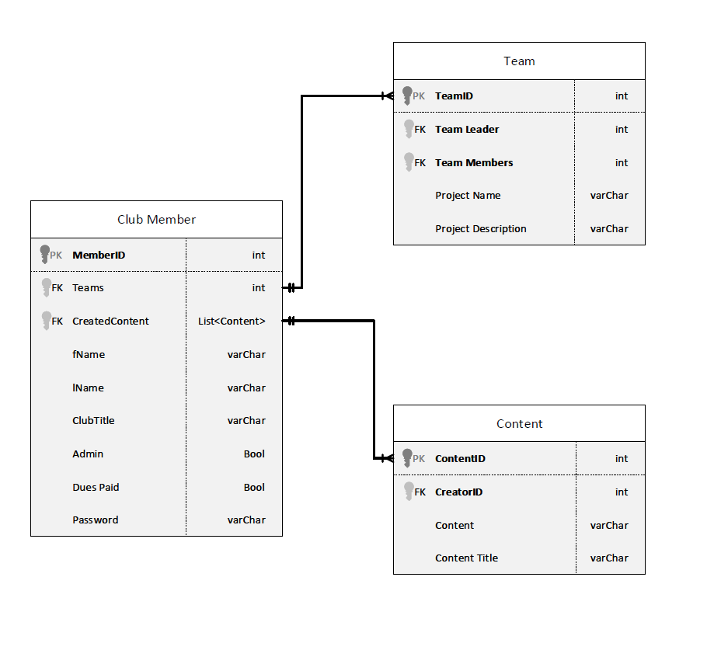  
Each club member will have an ID and a list of their posts tied to their record in the DB as well as the club members name. The posts will have a title, content and creator. Each club member will have a title in the club (member or officer). Officers will have the ability to create posts as well as edit posts created by other members. Membership status will also be tracked by the DB. Non-members and members that have not paid dues cannot create content within the site. Members will have the option of being assigned to a team by an officer. Each team works on a single project. Club members and officers can be on many or zero teams.

## SEQUENCE DIAGRAM

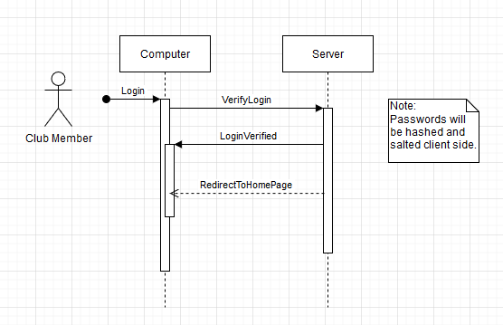

An example of a club member using the login sequence.

## USE CASE DIAGRAM

Use case showing how the actors will utilize they system. Club officer actions include all of the club members actions, but the ones specific to the Officer are highlighted in red. Secondary actors, prospective club members and clients, will have read access to the system.

